Math Problems

- A right conical frustum of base radius 7 cm and top radius 3.5 cm and height 6 cm is stuck onto a cylinder of base radius 7 cm and height 5 cm which is further attached to a hemisphere in order to form a closed solid as shown below.
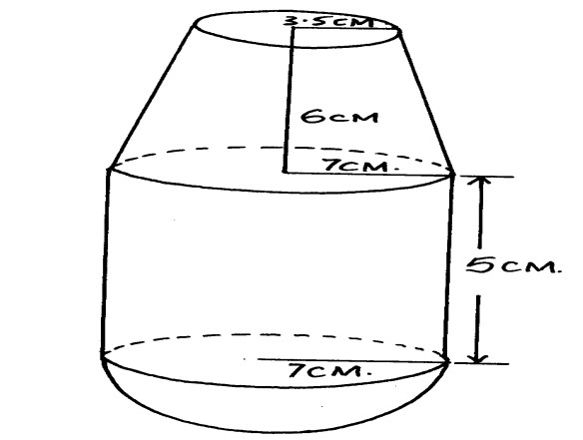
Find correct to 2 d.p ;
  - The volume of the solid. (5 marks)
  - The surface area of the solid. (5 marks)

- A school planned to buy calculators for a total cost of Ksh 16200. The supplier agreed to offer a discount of Ksh 60 per calculator. The school was then able to get three extra calculators for the same amount of money.
- Write an expression in terms of for the original price of each calculator (1 mark)
- Write an expression in terms of for the price of each calculator after the discount (8 mark )
- Form an equation in and hence determine the number of calculators the school bought (5 marks)
- Two lines 𝐿₁: 2𝑦 − 3𝑥 − 6 = 0 and 𝐿₂ ∶ 3𝑦 + 𝑥 − 20 = 0 intersect at point A
- Find the coordinates of A (3 marks)
- A third line 𝐿₃ is perpendicular to 𝐿₂ at point A. Find the equation of 𝐿₃ in the form 𝑦 = 𝑚𝑥 ± 𝑐 where m and c are constants (3 marks)
- Another line 𝐿₄ is parallel to 𝐿₁ and passes through (-1, 3). Find the 𝑥 𝑎𝑛𝑑 𝑦 intercepts of 𝐿₄ (4 marks)

- Four telephone posts PQR and S stand on a level ground such that Q is 28m on a bearing of 060⁰ from P. R is 20m to the south of Q and S is 16m on a bearing of 140⁰ from P.
- Using a scale of 1cm represent 4m show the relative positions of the posts. (5marks)
- Find the distance and bearing of R from S. (2marks)
- If the height of post P is 15.6m. on a separate scale drawing, draw a diagram and determine the angle of depression of bottom of post R from the top of post P.(Same scale as above) (3marks)

- Given the equation of a quadratic curve y = x² + 5x – 3
  - (i) Complete the table below for the function y = x² + 5x – 3 for -6 $≤$ x $≤$1 (2 marks)
x | -6 | -5 | -4 | -3 | -2 | -1 | 0 | 1
y |  | -3 | -7 |  | -9 |  | -3 | 3

    - Draw the graph of y = x² + 5x – 3 for -6 $≤$ x$≤$1 (3marks)

  - (i) State the equation of the line of symmetry for the graph (1mark)
    - Use the graph you have drawn to solve the equations;
x² + 5x – 3 = 0 (1mark)
x² + 4x – 2 = 0 (2marks)
x² + 5x – 3 = -3 (2marks)
- The table below shows marks obtained by form three students in Kiswahili third term exam.
Marks | 20-25 | 26-30 | 31-39 | 40-45 | 46-51 | 52-59 | 60-68 | 69-75 | 76-80
Frequency | 2 | 8 | 14 | 24 | 30 | 20 | 10 | 8 | 4
- Draw an ogive (3marks) From the ogive curve in (a) above estimate the median
- Calculate;
- Mean
- Mode
- Quartile deviation
- Standard deviation
- Discuss 5 methods of collecting primary data

